BOY LONDON, nowadays is one of the most famous street fashion brands in the world.
Many teens love it because shows the treason fashion: big logos which shows they are rich, loose shirts and leggings or sometimes super short pants to make them outstand. It is not that much expensive such as Gucci, Versace, Chanel. But it is also not cheap enough so that everyone could buy it. It’s price is a great way to let a teenage show his family circumstance. Not only some teenagers, but also some famous people loves it like Rihana and Lady Gaga… these famous person are also a very important point to make BOY more famous.

BOY LONDON was established in late 1960s by Stephane Raynor, the first BOY store were opened on the Kings Rd in 1976, which was now a very popular street fashion brands. BOY is one originator of street fashion brand. It has a very punk style logo, a eagle, which makes it looks like a brand for military, but it is just a brand for everyone who can buy it. All its design are kinds of punk and scrawl styles. And nowadays it is designing kind of navy style.
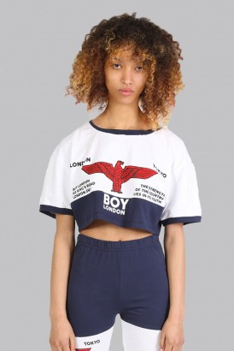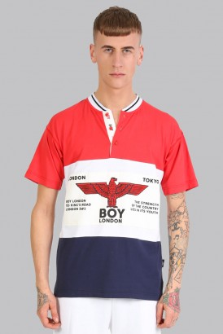
In my own opinion, I don’t like this brand very much, maybe it is very creative when it was born 50 years ago, but on nowadays, BOY’s style is very boring, monotonous. All its design are kinds of punk style—black, white and golden color, some pegs and skulls. but what kind of style I like are those which are colorful. Those kind of black and white looks much more boring for our teenagers. Maybe for someone it is a great choice in wearing black and white. Instead of BOY, I love those kind looks more official or colorful, like shirts.
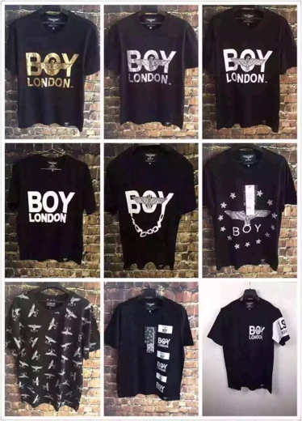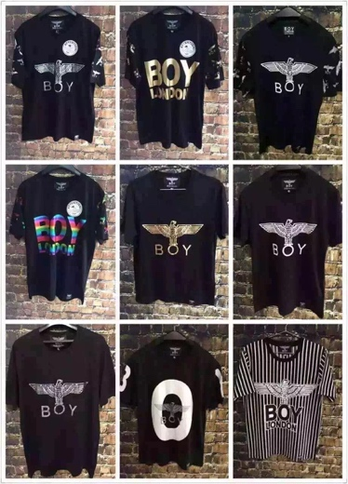

It had designed many jointly clothing, such as MARVEL x BOY LONDON, LONG CLOTHING x BOY LONDON, those popular joint will increase its popularity, and I have to say that it really make me love it a lot because I love marvel very much.
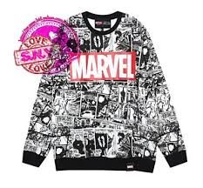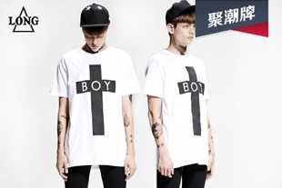

Whatever, for some fashion lovers, BOY is a great brand. In many ways I don’t like it but I can deny that it really is a great brand. It was vanguard, and it is fashion.

